EXPERIMENT NO. 5
Maximum Element of an Array with Least Time Complexity
Programming Language: Java
Name : A Yuvan Charan
Register No. : 192424383
Aim
To write a Java program that finds the maximum element of an array in the least possible time complexity.
Question
Write a program for the below test cases with the least time complexity.
Test Case 1
Input: {1, 2, 3, 4, 5}
Expected Output: 5
Test Case 2
Input: {7, 7, 7, 7, 7}
Expected Output: 7
Test Case 3
Input: {-10, 2, 3, -4, 5}
Expected Output: 5
Algorithm
Step 1: Start.
Step 2: Read the array arr of size n.
Step 3: Set max = arr[0].
Step 4: For i from 1 to n-1, if arr[i] > max then set max = arr[i].
Step 5: Print max.
Step 6: Stop.
Program (Java)
public class Main {

static int findMax(int[] arr) {
int max = arr[0];
for (int i = 1; i < arr.length; i++) {
if (arr[i] > max)
max = arr[i];
}
return max;
}

public static void main(String[] args) {
int[] t1 = {1, 2, 3, 4, 5};
int[] t2 = {7, 7, 7, 7, 7};
int[] t3 = {-10, 2, 3, -4, 5};

System.out.println("Test Case 1 Output: " + findMax(t1));
System.out.println("Test Case 2 Output: " + findMax(t2));
System.out.println("Test Case 3 Output: " + findMax(t3));
}
}
Output
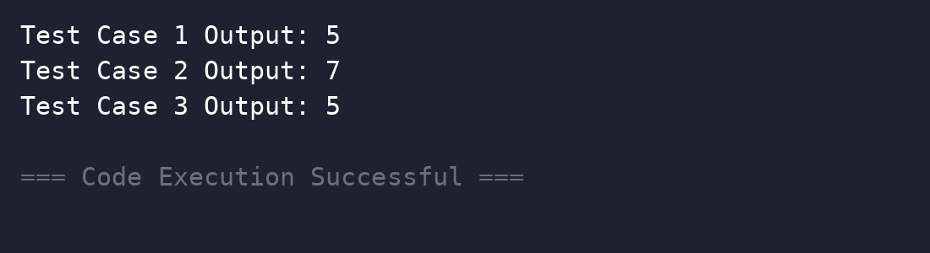
Complexity Analysis
Time Complexity: O(n) - a single pass; this is optimal because every element must be examined at least once.
Space Complexity: O(1)
Result
Thus the program was executed successfully and the output was verified.

